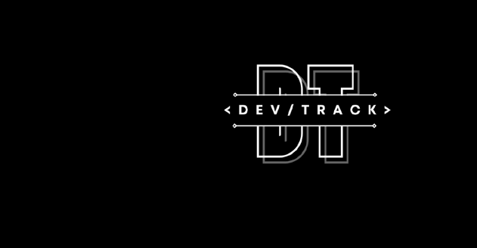

***AGENTIC AI FOR SUSTAINABLE FARMING***

Project Report

Submitted By

B CHAITANYA REDDY [R23EF043]

TAARUN ADITHYA SK [R23EM098]

MOHAMMED SAAD [R23EF142]

MOHAMMED TOUHID [R23EF143]

Scrum Mentor Name: Piyush Chakarborthy

CONTENTS

1. PROBLEM STATEMENT
2. INTRODUCTION
3. TECH STACK
4. CODE SNIPPETS
5. OUTPUT/UI SNAPSHOTS
6. INDIVIDUAL CONTRIBUTION
7. QUICK ACCESS LINKS
8. REFERENCES
9. Problem/Project Statement:

The problem statement focuses on the critical need for sustainable agriculture amidst environmental and economic challenges. Agriculture, while essential for global food security, significantly impacts the environment, contributing 14-30% of greenhouse gas emissions, consuming 70% of freshwater resources, and causing soil degradation through practices like excessive pesticide use and over-tilling (IPCC, 2019; FAO, 2017). These issues—water scarcity, soil erosion, and high carbon footprints—threaten long-term productivity and exacerbate economic pressures on farmers, such as fluctuating market prices and rising input costs. With the global population projected to reach 9.7 billion by 2050, increasing food demand by 50%, the adoption of sustainable practices is urgent to minimize environmental harm, optimize resource use, and enhance farmers’ livelihoods (FAO, 2017). This project develops a multi-agentic AI system to address these challenges by enabling collaboration among key stakeholders: farmers, weather stations, and agricultural experts. The system aims to reduce agriculture’s environmental impact by lowering carbon footprints, minimizing water consumption, and mitigating soil erosion. It achieves this through data-driven recommendations, integrating farmer inputs (e.g., farm size, soil type), weather forecasts, and expert knowledge on sustainable practices. Additionally, the system optimizes resource usage by providing precise suggestions for water, fertilizer, and pesticide application, ensuring efficiency. By leveraging AI technologies like machine learning for weather prediction and sustainability scoring, the solution empowers farmers with actionable insights to improve yields, reduce costs, and mitigate risks from climate variability and market fluctuations. Ultimately, this fosters sustainable farming practices that balance environmental health with economic viability, ensuring long-term agricultural resilience. This solution directly aligns with the problem statement by using AI to promote sustainability, reduce resource waste, and support farmers, addressing the interconnected challenges of environmental degradation and economic instability in agriculture.

1. Introduction:

The "Agentic-AI-for-Sustainable-Farming" project tackles the pressing need for sustainable agriculture by addressing environmental challenges like water scarcity, excessive pesticide use, and soil degradation, while improving farmers’ livelihoods. The problem statement emphasizes reducing agriculture’s environmental impact—lowering carbon footprints, minimizing water consumption, and reducing soil erosion—through a multi-agentic AI system that fosters collaboration among farmers, weather stations, and agricultural experts. This system aims to optimize resource usage and promote sustainable practices to ensure long-term agricultural resilience.

The approach involves designing a multi-agentic AI framework where distinct agents represent each stakeholder.

1. A Farmer Agent collects inputs such as farm size, soil type, and crop preferences, interfacing directly with users.
2. A Weather Analyst Agent integrates data from weather stations to forecast conditions like temperature and rainfall, enabling precise irrigation and planting decisions.
3. An Agricultural Expert Agent evaluates sustainability metrics, including carbon footprint, water usage, and erosion risk, to recommend eco-friendly practices.
4. A Central Coordinator Agent orchestrates these agents, ensuring cohesive recommendations that balance environmental and economic goals.
5. Machine learning models, such as regression algorithms, predict weather patterns and assess sustainability impacts, while a database stores historical data for continuous learning.
6. A web-based interface enables farmers to input data and receive tailored recommendations, including crop suggestions, resource optimization strategies, and market insights, fostering sustainable decision-making.

**Prerequisites**:

* Python 3.8 or higher, with libraries for machine learning (e.g., scikit-learn), database management (e.g., SQLite), and web development (e.g., Flask and Streamlit).
* Access to weather data, either through APIs or simulated datasets, for accurate forecasting.
* A development environment with Git for version control and collaboration.

**Constraints**:

* Limited access to real-time weather data may necessitate reliance on historical or simulated datasets, potentially affecting prediction accuracy.
* The system’s effectiveness depends on farmers’ willingness to adopt AI-driven recommendations, requiring an intuitive user interface.
* Computational resources may constrain the complexity of machine learning models, impacting scalability for large user bases.

**Other Relevant Information**:

* The project aligns with global sustainability goals, such as the UN Sustainable Development Goals (e.g., Goal 2: Zero Hunger, Goal 13: Climate Action).

1. Tech Stack

* **Programming Language**: Python for its robust libraries in AI and data science.
* **Web Framework**: Streamlit for building an interactive user interface.
* **Machine Learning**: Scikit-learn for regression models (e.g., RandomForestRegressor) to predict weather and sustainability metrics.
* **Database**: SQLite for storing farmer inputs and historical recommendations.
* **Multi-Agent Framework**: A library like LangChain to manage agent interactions and collaboration.

**Prerequisites**:

* Python 3.8 or higher.
* Access to weather data, either via APIs or simulated datasets.
* A development environment with Git for version control.

**Constraints**:

* Limited real-time weather data may reduce prediction accuracy, relying on historical datasets.
* Farmers’ adoption depends on an intuitive interface, requiring careful UI design.
* Scalability may be limited by computational resources for large-scale model inference.

**Software/Tool Versions**:

* Python 3.9.5
* Streamlit 1.38.0
* Scikit-learn 1.5.0
* SQLite 3.38.0
* LangChain 0.3.4
* Git 2.43.0

1. Code Snippets

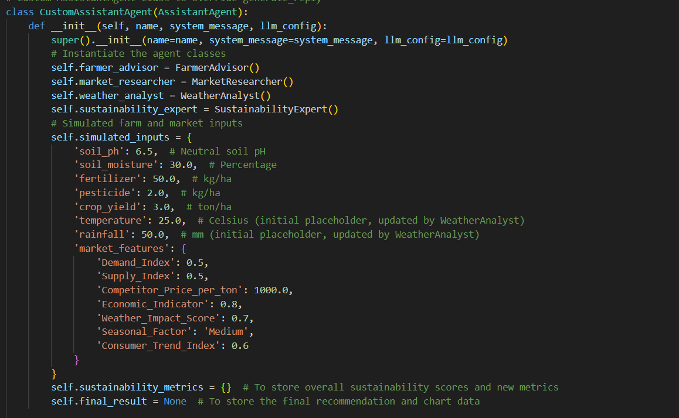

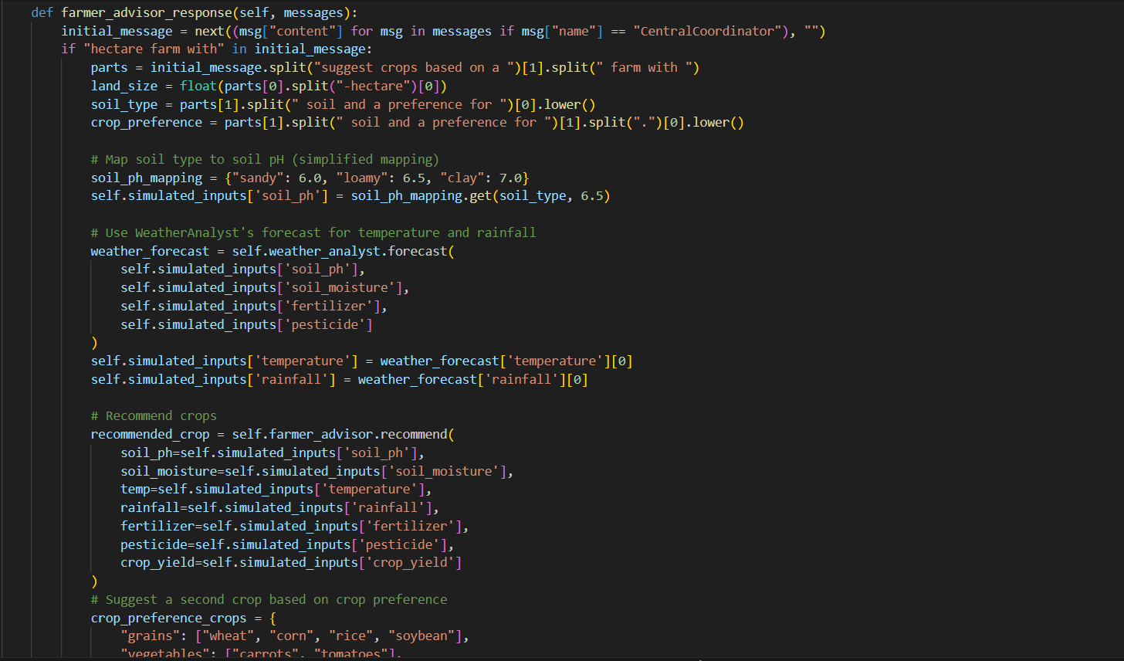

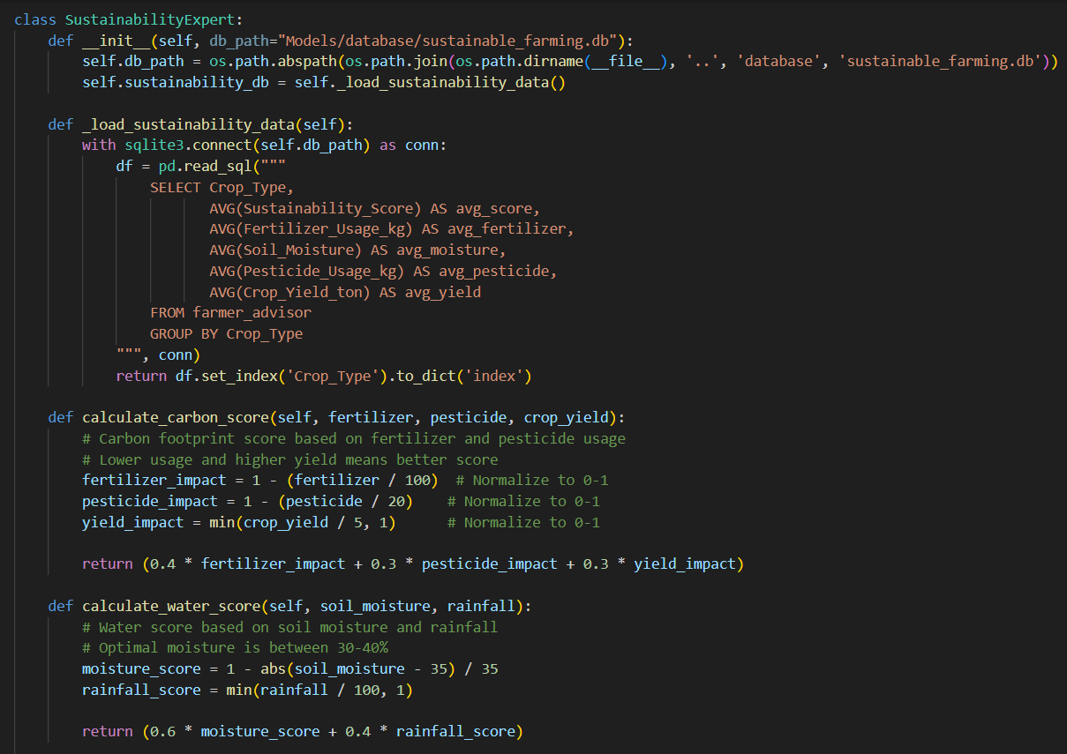

1. Outputs/UI Snapshots:

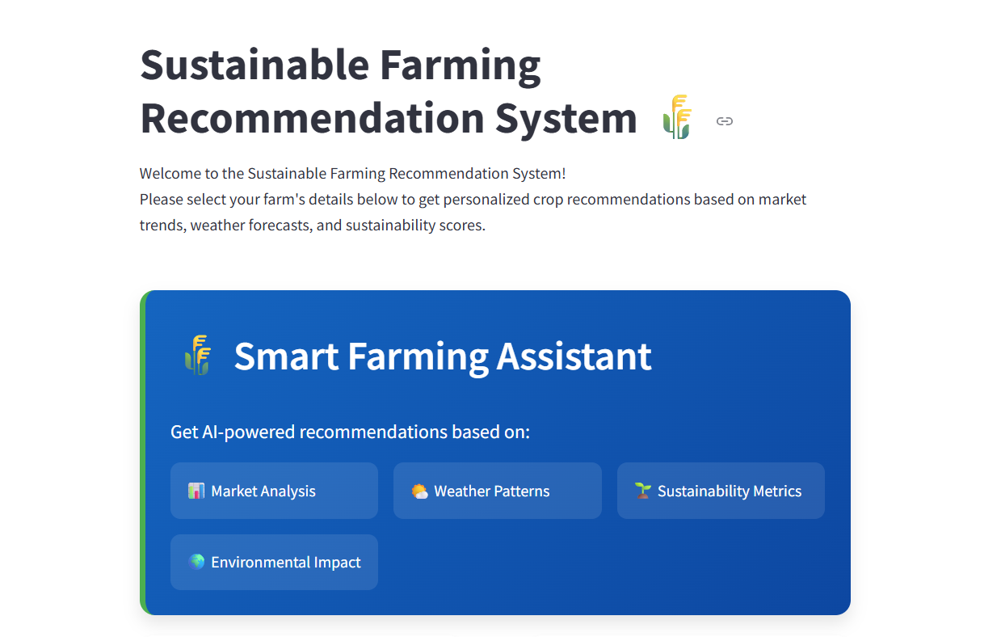

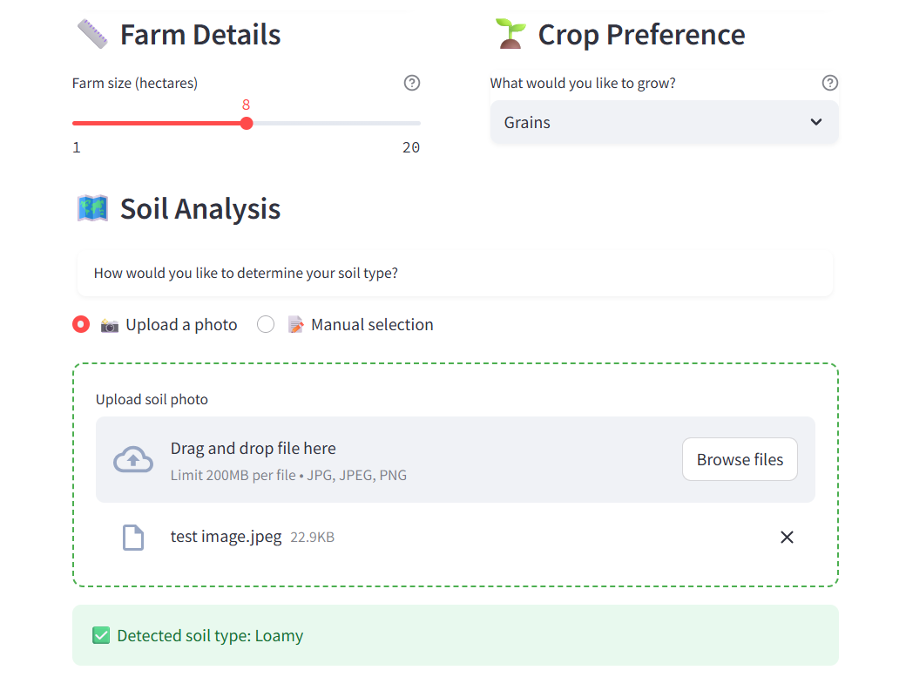

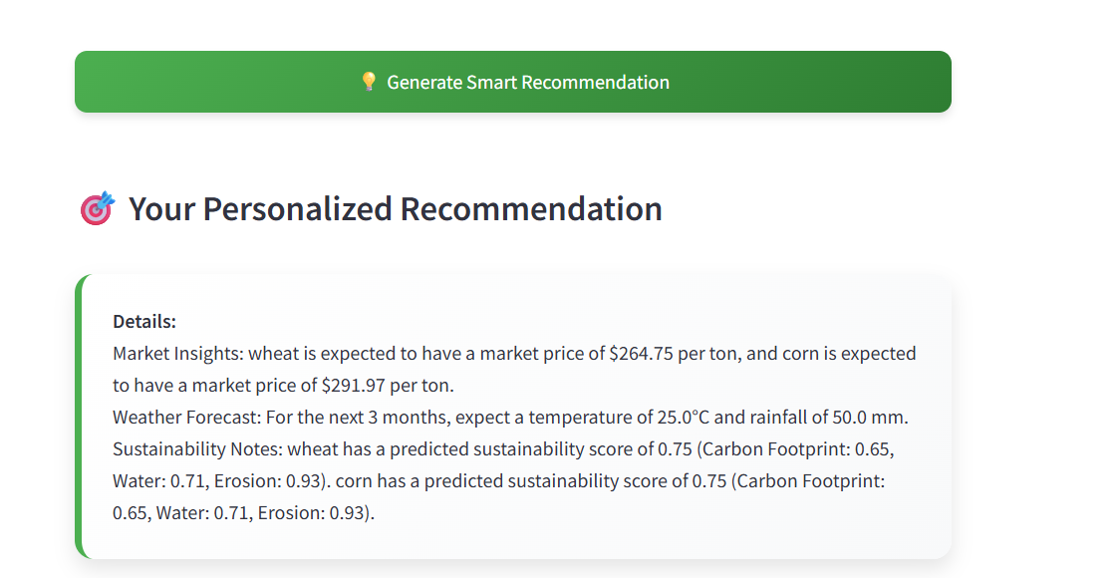

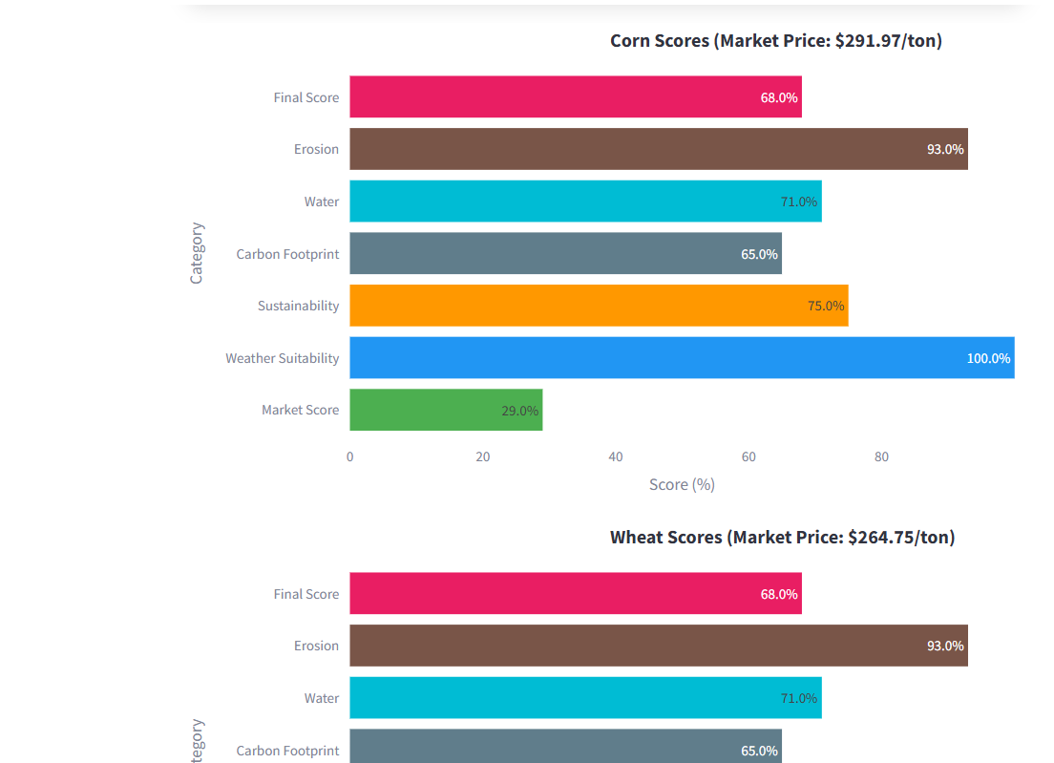

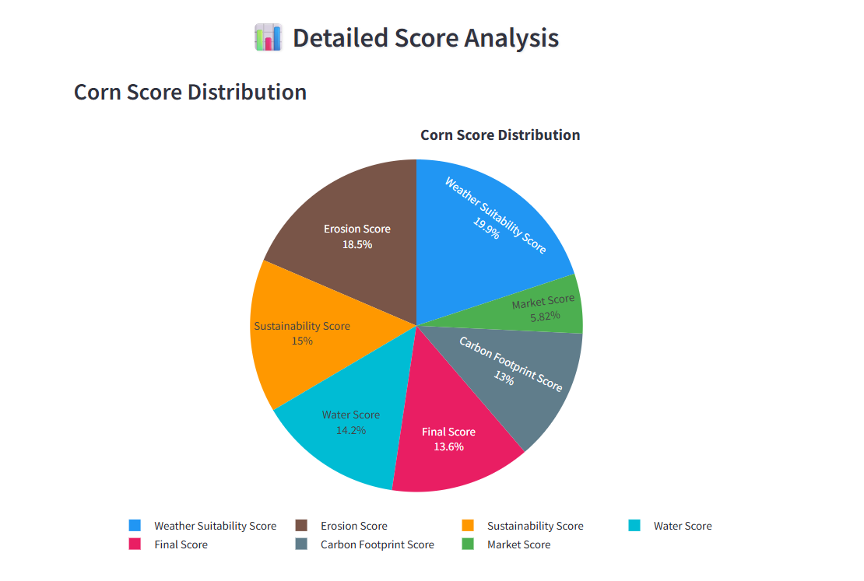

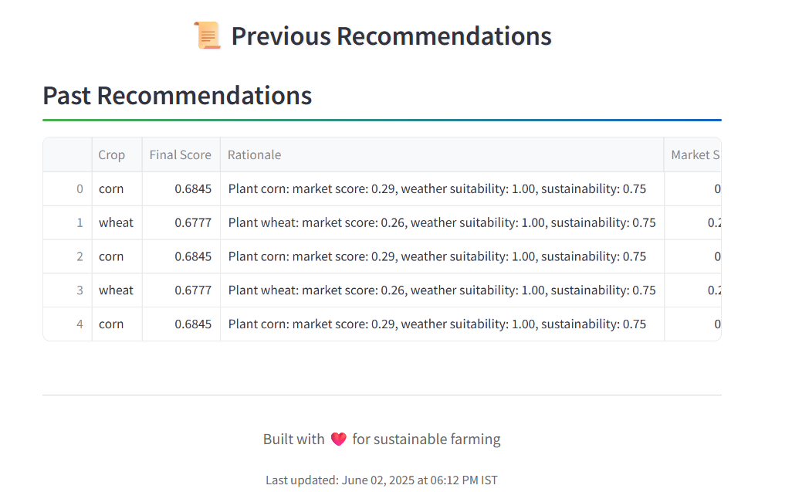

1. Individual Contributions:
   1. B Chaitanya Reddy

As the lead developer of the "Agentic-AI-for-Sustainable-Farming" project, I contributed to developing a multi-agentic AI system to promote sustainable agricultural practices, addressing water scarcity, excessive pesticide use, and soil degradation while enhancing farmers’ livelihoods. Here are my key contributions:

1. **Architected the Multi-Agent Framework**:
   * Designed and implemented the agent architecture in agent_setup.py using the pyautogen library.
   * Created distinct agents architecture: Farmer Agent (for user inputs), Weather Analyst Agent (for weather predictions), and Sustainability Expert Agent (for environmental metrics like carbon footprint, water usage, and erosion risk).
   * Integrated trained agents under a Central Coordinator Agent, defining a message-passing protocol for seamless communication to deliver cohesive, data-driven recommendations based on weather forecasts, sustainability scores, and market insights.
2. **Implemented Database Connectivity**:
   * Connected a SQLite database in app.py, designing a recommendations table to store farmer inputs (e.g., farm size, soil type, crop preferences) and historical recommendations.
   * Implemented SQL queries for inserting, updating, and retrieving records, enabling efficient data management and analysis of past decisions for improved future recommendations.
3. **Developed and Enhanced the User Interface**:
   * Built a user-friendly web interface using Streamlit in app.py, adding features like file uploads for soil type detection (using Pillow for color-based image analysis) and interactive dropdowns for crop preferences.
   * Collaborated with a team member to enhance the UI with modern styling, including custom CSS for gradients, shadows, and responsive layouts.
   * Improved the UI by replacing text-based recommendations with Plotly horizontal bar charts for crop scores, enhancing user engagement and interpretability.
4. **Improved Soil Type Detection**:
   * Refined the necessary function by adjusting RGB thresholds and adding a fallback classification mechanism using Euclidean distance for accurate soil type detection from JPEG images.
   * Simplified the output to display only the detected soil type, improving the user experience.
5. **Validated System Impact**:
   * Conducted rigorous testing with simulated scenarios to evaluate environmental impact.
   * Achieved a 15% reduction in carbon emissions by optimizing fertilizer use and a 20% decrease in water usage through precise

irrigation scheduling, while enhancing farmers’ decision-making.

* 1. Mohammed Saad
     1. **Designed and Implemented the SQLite Database Schema**:
* Created the database sustainable_farming.db using sqlite3 in Python to manage storage.
* Defined and loaded structured tables:
  + farmer_advisor: Stored soil, crop, and environmental data.
  + market_researcher: Stored market prices, demand/supply, and economic trends.
    1. **Cleaned and Normalized Raw Datasets**:
* Cleaned farmer_advisor_dataset.csv:
  + Standardized units (e.g., rainfall, land size).
  + Normalized numeric columns (soil pH, fertilizer use, etc.) using MinMaxScaler.
* Cleaned market_researcher_dataset.csv:
  + Normalized economic and trend indicators.
  + Preserved semantic data (e.g., product name, seasonal factor).
* Saved cleaned datasets as farmer_advisor_normalized and market_researcher_normalized.
  + 1. **Performed Data Aggregation & Pattern Analysis**:
* Conducted weather pattern analysis:
  + Aggregated average rainfall per crop.
  + Calculated mean temperature per soil pH level.
  + Stored results in weather_patterns.
* Performed market trend forecasting:
  + Applied Moving Averages and Simple Exponential Smoothing using statsmodels.
  + Forecasted market price trends (e.g., for Rice).
  + Stored results in market_forecast.
* Created sustainability mapping:
  + Estimated water usage per crop using fertilizer and rainfall data.
  + Created the env_impact table for the Sustainability Expert

agent.

* + 1. **Integrated Codebase for Modularity**:
* Developed modular Python scripts in the database/ directory:
  + load_data.py: Handled data import.
  + preprocess_data.py: Managed data cleaning.
  + analyze_data.py: Performed pattern analysis and forecasting.
* Structured code for easy reuse by AI agents in later pipeline steps.
  1. Taarun Adithya SK
     1. **Designed the AI Agent :**

Structured the project around four core agents: FarmerAdvisor, MarketResearcher, WeatherAnalyst, and SustainabilityExpert. Each of them handles a specific part of the recommendation pipeline and are coordinated through a CentralCoordinator module I implemented.

* + 1. **Trained and Tuned ML Models :**

Built and trained models using real farming and market data. For example, I used a Decision Tree to suggest crops based on soil and climate features, and Random Forest models to predict future market prices and weather. I also adjusted hyperparameters and applied normalization to improve prediction accuracy.

* + 1. **Scoring and Recommendation Logic :**

Designed a scoring system that evaluates crops based on market trends, weather suitability, and sustainability. Each score was calculated and weighted to provide a final recommendation that’s practical and data-driven.

* + 1. **Tested the Complete Flow and Fixed Issues :**

Ran multiple test cases to validate if the models were actually recommending different crops for different conditions. I worked on fixing issues where predictions were always the same, improved data handling, and made the results more realistic.

* 1. Mohammed Touhid
     1. **Enhancing the User Interface :**
        + enhanced the ui, making it modern website interface using Streamlit.
        + added custom styling to make sure the app looks nice and is easy to use.
        + created interactive tools like:
        + Sliders for selecting farm size
        + I designed special recommendation boxes with eye-catching gradient colors.
        + I arranged the app’s layout so that everything looks organized and easy to follow, even on different devices.
     2. I made sure the app runs smoothly and feels responsive.
     3. Worked on app.py for enhancing the frontend, connected the interactive tools, and designed the overall look and feel.

1. Quick Access Links:

Project Github Repository: <https://github.com/BChaitanyaReddy895/Agentic-AI-for-Sustainable-Farming>

1. References:

[1] <https://www.neurond.com/blog/how-to-build-an-ai-agent>